Bellingham's Midas touch saves tired England
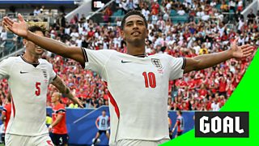
'Man of all the moments' - Bellingham gives England the lead for the first time in the game
England were unable to repeat the heroics of their magnificent last-16 victory against Mexico in Azteca Stadium, perhaps understandably looking jaded after their exertions there, followed by these stifling conditions in Miami.
Where there is Bellingham, however, there is hope - and once again the Real Madrid star provided the moments that define and decide big games.
Bellingham's reaction after showing superb technique to equalise three minutes into first-half stoppage time was remarkable, simply turning and running back to the centre circle in businesslike fashion before whipping up England's fans.
England suffered in the sweltering second-half conditions as both teams tired, but it was Bellingham again who made the decisive contribution, reacting first to Nyland's slip to settle a game of fine margins.
It takes Bellingham's tally to six goals at the World Cup as he continues on what almost looks like a personal mission to bring glory to England.

Haaland kept quiet as England prevail

Norway goal ruled out after VAR intervention
Haaland has emerged as one of the stars of this World Cup on and off the pitch with his seven goals leading Norway to the quarter-finals, while his personality has won the hearts of the United States.
This, however, was one game too far for the Manchester City striker, who has had a magnificent tournament, to exert his influence.
He threatened fleetingly, almost cashing in on a loss of concentration by John Stones in the first half, and was left frustrated when, with Norway 1-0 up, Alexander Sorloth inexplicably decided to go it alone rather than pass to the unmarked Haaland, who had a clear run on goal.
The final frustration came when he shoved Anderson in an incident that meant Heggem's goal, that would have restored Norway's lead, was ruled out.
Haaland knew what was coming after the video assistant referee (VAR) intervened, barely celebrating.
This was a day of disappointment, but his personality has captured the public's imagination after a World Cup that has brought great pride to Haaland and Norway.

